<Online Auction>

Requirements Specification and Analysis

<1.0>

<11.11.2018>

<TOLGA GÜLDÜTUNA

FEYZULLAH BEERKAY DANIŞ

BERKAY YILMAZ

TEKİN EVRİM>

Prepared for

SE301 Software Engineering



Table of Contents

1. Introduction 1

1.1. Purpose of the System 1

1.2. Scope of the System 1

1.3. Objectives and Success Criteria of the Project 1

1.4. Definitions, Acronyms, and Abbreviations 1

1.5. Overview 1

2. Current System 1

3. Proposed System 1

3.1. Overview 1

3.2. Functional Requirements 2

3.3. Nonfunctional Requirements 2

Usability 2

Reliability 2

Performance 2

Supportability 2

Implementation 2

Interface 2

Packaging 2

Legal 2

3.4. System Models 2

Scenarios 2

Use case model 2

Object model 2

Dynamic model 2

User interface—navigational paths and screen mock-ups 3

3.5. Project Schedule 3

4. Glossary 3

5. References 3

REQUIREMENTS ANALYSIS DOCUMENT[1]

**

# Introduction

**

## Purpose of the System

The purpose of the auction app is to provide an app where people can buy or sell products on an online auction by using their phones

## Scope of the System

Users will be able to search the products that they want by entering information about the product and view any product on the auction app, they will be able to see information about the product such as price, category, name and other information depending on the category. Users can sign up to the system and by doing that they will be able to buy a product on the auction app by making an offer for the product on the auction. Registered users will also be able to put a product on an auction and sell it on the auction app but in order to do that they need to get approval from admin. Admin will be able to edit user profiles or delete a user. Registered users will be able to freeze their account and by doing that they will stop any kind of action taking place through their account. If users confronts any problem while using the system they will be able to communicate with admin.

## Objectives and Success Criteria of the Project

The purpose of the Online Auction System is to provide the users a mobile app that allowes people to buy or sell products on online auctions. This app will provide users a service that they will be able to make offer and buy a product on an auction or sell a product on an auction using very little number of steps. Users will be able to do that through their phone anywhere. They will be supported if they confronted a problem while using the system

## Definitions, Acronyms, and Abbreviations

Admin: Admin is an actor in auction app, admin is the actor who manages everything about auction app.

Registered User: An actor of the system, registered user is a user who signed up to the system to be able to buy or sell products.

User: A user who has not signed up to the system and so visitor is not able to buy or sell products.

## Overview

*Rest of the RAD contains non-functional (includes usability, reliability,

performance, supportability, implementation, interface, operational, packaging,

and legal requirements) and functional requirements (includes high-level

functionality of the system).

*System models are given. Scenarios are in side of system models section. Scenarios are to tell us the details of functional requirements. Use case models (definitions & diagrams), object model (UML diagram ),dynamic model(functiions of the sequence diagrams) , user interface view (mockup) and Project Schudule (Gantchart) are parts of system models.

section.

*Finally, RAD consist of two parts. These ara glossary (dictionary) and references (digital sources).

# Current System

**

# Proposed System

**

## Overview

Our auction application is an mobile auction style trade app that can be used by everyone from students to seniors.You can use the application as a user to look around or registered user to participate or create your own auction.People will always want to sell their products but there is always a hard part and it is pricing the product that you are going to sale. By auction application the user can get the maximum amount of money of their product because buyers decides the price for it. Users can only see the ongoing auctions and their details for so, registered users are can create their own auctions just simply clicking few buttons. It can be an auction for books to paintings or so.Every registered user can bid for an auction by just selecting to amount to bid and after the procces anytime he/she wants can look at their previous bids.There is a lot of difference between being a user and registered user but the bigger difference begins with the admin permissions. Admins are the key of the auction procces. When a registered user creates an auction, the auction approval send to the admin and admin should approve the pending auction application.Without approvement the auction will never go live.Admin can also ban a user’s account that scammed another user or violate any other policies. Registered users previous won or lost auctions can be see their profile pages. Admins and other users will also be able to look each others profile pages also.

## Functional Requirements

Our application is a mobile online auction manager/publisher/analyser platform for everyone who wants to buy or sell items through their mobile phones and easily and most importantly fast.

On the registered users side the application has several functions to offer such as , they can look through the going auctions through the main page and if they want to make a bid to them they will do it easily. Or they can just simply want to create an auction they can make it easy and fast through the application.

On the user side. Users are just downgraded versions of the registered users. They can just use the main page to check some auctions going on and get notified.If they want to participate for an auction they have to register to do so.

Admins are the ones who controls the all procces by simply just giving approvement to the pending auctions so everyone can see. Also they can freeze the users who are not being respectfull to the rules. Admins can also reach to the users profile and also make some looking.To sum up. The most important function is the “approve” fuction the system has to offer because with it the auctions will be available for all.

## Nonfunctional Requirements

### Usability: For a person who wants to bid for an auction should make 12 clicks to register (including clicks made for login and approve bid, register procces)

### Reliability: Application servers should be running %100 of the time to application runs.

### Performance: System should must allow least 1000 parallel users.

### Supportability: The system should be maintained and changeable easily

### Implementation: NEYLE YAZICAZ

### Interface: The interface should be implemented with android studio.

### Packaging:

### Legal : The software is provided “as is”, without warranty of any kind,express or implied including but not limited to the warranties of merchantability, fitness for a particular purpose and no infringement. In no event shall the authors or copyright holders be liable for any claim, damages or other liability. Whether in an action of contract, tort or otherwise, arising from, out of or in connection with the software or the use or other dealings in the software.

## System Models

**

### Scenarios

Admin Scenarios

|  |  |
| --- | --- |
| *Scenario name* | **Deleting/Freezing a registered user** |
| *Participating actors* | Berkay as Admin  Ali as Registered User |
| *Flow of Events* | 1. Berkay as an admin opens his application via his mobile phone to ban Ali’s account because of Ali’s fraud intention on an auction.Berkay logs in to the system by entering his username and password and clicking “log in” button. 2. After berkay opened his admin account he opened his profile section by clicking on the profile button on the screen. And after berkay clicked the profile page opens. 3. Berkay clicks on the users section on the main menü and the section opens up in a new page, Berkay clicks the search area and writes Ali’s username there and then clicks search. 4. Berkay clicks the edit button next to the name of corresponding username and the editing page opens up. 5. Berkay checks the “Ban” button in the users page and then clicks “save” button to complete the banning task. |

|  |  |
| --- | --- |
| *Scenario name* | **Updating an users status/info** |
| *Participating actors* | Berkay as Admin  Tolga as Registered User |
| *Flow of Events* | 1. Berkay as an admin opens his application via his mobile phone to promote Tolga’s account to become a Editor. Berkay logs in to the system by entering his username and password and clicking “log in” button. 2. After berkay opened his admin account he opened his profile section by clicking on the profile button on the screen. And after berkay clicked the profile page opens. 3. Berkay clicks on the users section on the main menü and the section opens up in a new page, Berkay clicks the search area and writes Tolga’s username there and then clicks search. 4. Berkay clicks the edit button next to the name of corresponding username and the editing page opens up. 5. Berkay clicks to the “Promote as editör” section in the settings of the Tolga’s account and he approves the task by clicking the “Yes” button on the screen that ask for approval from berkay. |

|  |  |
| --- | --- |
| *Scenario name* | **Viewing Messages and reply** |
| *Participating actors* | Berkay as Admin  Gözde as Registered User |
| *Flow of Events* | 1. Berkay as an admin opens his application via his mobile phone to do some inbox check and return customer messages. He enters his username and password to log in as an admin 2. Berkay clicks the “My messages” section and messages page opens up. Berkay looks for the messages and opens the user Gözde’s message. 3. Message page opens up and berkay reads the full message on this page and After reading Gözdes message , an information mail send to gözde tol et her know her issue is being issued. |

|  |  |
| --- | --- |
| *Scenario name* | **Log-in as Admin** |
| *Participating actors* | Berkay as Admin |
| *Flow of Events* | 1. Berkay as an admin opens his application via his mobile phone and he enters his username and password to log in as an admin and then he clicks to “Log in” button. 2. Berkay succesfully logs in to the app.. |

|  |  |
| --- | --- |
| *Scenario name* | **Approving an Auction** |
| *Participating actors* | Berkay as Admin |
| *Flow of Events* | 1. Berkay as an admin opens his application via his mobile phone to do some auction approving. He enters his username and password to log in as an admin 2. After berkay opened his admin account he opened his profile section by clicking on the profile button on the screen. And after berkay clicked the profile page opens. 3. He selects the pending auctions section by clicking on it and the applications page opens up.Berkay looks at the applications and checks the application creaters information, application info and checks its avaliablity. 4. Berkay decides to approve or deny the application through its information and clicks the corresponding button either “approve” or “decline” |

Registered User Scenarios

|  |  |
| --- | --- |
| *Scenario name* | **Freezing Account on the auction app** |
| *Participating actors* | Ali as Registered User |
| *Flow of Events* | 1. Ali wants to freze his account, so he clicks on my account on home page. 2. Ali clicks on the freeze account button on the page. |

|  |  |
| --- | --- |
| *Scenario name* | **Signing in to the auction app** |
| *Participating actors* | Ali as Registered User |
| *Flow of Events* | 1. Ali wants to use his account, so he clicks on the login icon on the home page. 2. Ali writes his Registered Username and password and clicks on login button. |

|  |  |
| --- | --- |
| *Scenario name* | **Signing out of auction app** |
| *Participating actors* | Ali as Registered User |
| *Flow of Events* | 1. Ali clicks on sign of button. |

|  |  |
| --- | --- |
| *Scenario name* | **Giving an offer for an item** |
| *Participating actors* | Ali as Registered User |
| *Flow of Events* | 1. Ali selects an item that he wants and clicks on it. 2. Ali enters an amount of Money for the item, more than the last offer or starting price and clicks on apply button. |

|  |  |
| --- | --- |
| *Scenario name* | **Selling an item on auction app** |
| *Participating actors* | Ali as Registered User |
| *Flow of Events* | 1. Ali wants to sell an item, so he signs in to the auction app. 2. Ali clicks on sell item button. 3. Ali enters the name and description of the item and clicks on the put it on auction button. |

|  |  |
| --- | --- |
| *Scenario name* | **Searching an item on auction app** |
| *Participating actors* | Ali as Registered User |
| *Flow of Events* | 1. Ali wants to see the items on the auction app before buying one, so he opens the app on his phone. 2. Ali writes information about a certain product in the searchbox and clicks on search. |

|  |  |
| --- | --- |
| *Scenario name* | **Viewing an item on auction app** |
| *Participating actors* | Ali as Registered User |
| *Flow of Events* | 1. Ali wants to obtain information about an item, so he opens the app. 2. Ali selects and item and clicks on it. |

|  |  |
| --- | --- |
| *Scenario name* | **Sending a message** |
| *Participating actors* | Ali as Registered User |
| *Flow of Events* | 1. Ali has a message he wants to send someone so he opens the app on his phone. 2. Ali enters his Registered Username and password and logins to the system. 3. Ali clicks on message box button. 4. Ali writes a message, subject and reciever’s name and clicks on send. |

|  |  |
| --- | --- |
| *Scenario name* | **Checking Messages** |
| *Participating actors* | Ali as Registered User |
| *Flow of Events* | 1. Ali has a message he wants to send someone so he opens the app on his phone. 2. Ali enters his Registered Username and password and logins to the system. 3. Ali clicks on message box button. 4. Ali opens one of the messages. |

User Scenarios

|  |  |
| --- | --- |
| *Scenario name* | **User on Home Page** |
| *Participating actors* | Tekin:User |
| *Flow of Events* | 1. Tekin wants to learn which items will be sell with auction. He opened the application and saw the home page. 2. Items are listed on him, he wants to know details about an item and clicked on that. 3. App redirects him to detail page. He sees detail of item and auction which has been continuing. |

|  |  |
| --- | --- |
| *Scenario name* | **User on Detail Page** |
| *Participating actors* | Tekin:User |
| *Flow of Events* | 1. Tekin wants to see detail of item. He clicks item on item list and redirect detail page. 2. After detail page opened, he sees photos, name, infos and auction details which has been continuing. |

|  |  |
| --- | --- |
| *Scenario name* | **User Searchs an Item** |
| *Participating actors* | Tekin:User |
| *Flow of Events* | 1. Tekin wants to search an item. He can search both of name or category. He types search bar on home page and clicks search button. 2. Items are listed on him about his search. He clicks an item which wanted to see details.p |

|  |  |
| --- | --- |
| *Scenario name* | **User Logins** |
| *Participating actors* | Tekin:User |
| *Flow of Events* | 1. Tekin wants to login application. He clicks login button and redirects login screen. 2. After redirecting login screen he fill login form with credentials and redirecting home page with user authentication |

|  |  |
| --- | --- |
| *Scenario name* | **User Registers** |
| *Participating actors* | Tekin:User |
| *Flow of Events* | 1. Tekin wants to register application. He clicks register button and redirects register screen. 2. After redirecting register screen he fill login form with credentials and redirecting home page with user authentication |

### Use case model

Use case definitions

* Admin’s Use Case Definitions

|  |  |
| --- | --- |
| *Use case name* | **ViewUser** |
| *Participating actors* | Admin |
| *Flow of events* | 1. The Admin opens the application through his/hers phone 2. He/She enters the users page by clicking on it 3. Admin clicks to the search bar that opened in the users page and writes the wanted user’s name to the bar. 4. System shows the avaliable user(s) fort he search term or shows the “no user” message to the admin. |
| *Entry condition* | * Admin has to be logged in |
| *Exit condition* | * Admin succesfully gets the info of the User OR * The Username is not avaliable |
| *Exceptional*  *Cases* | * [There is no User]: If the Username is not saved on the database , The system shows “no user” result. |

|  |  |
| --- | --- |
| *Use case name* | **FreezeUser** |
| *Participating actors* | Admin |
| *Flow of events* | 1. The Admin opens the application through his/hers phone 2. He/She enters the user page by clicking on it. 3. Admin clicks to the search bar and enters the name of the user. 4. System shos the avaliable user list fort he search term 5. Admin clicks the Icon next to users name for the delete/freze operation 6. System opens a “Are you sure” message. 7. Admin clicks the “YES” button and user succesfully deletes/freezes |
| *Entry condition* | * Admin has to be logged in |
| *Exit condition* | * Admin succesfully deletes the user OR * The Username is not avaliable |
| *Exceptional*  *Cases* | * [There is no User]: If the Username is not saved on the database , The system shows “no user” result. |

|  |  |
| --- | --- |
| *Use case name* | **Logout** |
| *Participating actors* | Admin |
| *Flow of events* | 1. The Admin opens the application through his/hers phone 2. Admin opens the profile section 3. Admin clicks the logout button that is on his/hers profile section 4. Admin succesfully logged out and directed to the main page. |
| *Entry condition* | * Admin has to be logged in |
| *Exit condition* | * Admin succesfully logs out |
| *Exceptional*  *Cases* |  |

|  |  |
| --- | --- |
| *Use case name* | **Login** |
| *Participating actors* |  |
| *Flow of events* | 1. The Admin opens the application through his/hers phone  2. Admin clicks the log in button that is on the screen  3. Admin enters his/hers username and password the the given blank spots.  4. Admin clicks to the log in button |
| *Entry condition* | * Login page must be opened |
| *Exit condition* | * Admin succesfully logs in OR * Admin gets a message thet shows why he/she cant log in |
| *Exceptional*  *Cases* | * [Invalid character]: If the system detects an invalid character entered in the username or password section , system will send an error message with the details of it. * [Invalid Username or Password]: If the username and password are not matched in the database , system will give an error message saying “Invalid username or password”. |

|  |  |
| --- | --- |
| *Use case name* | **Approve** |
| *Participating actors* | Admin |
| *Flow of events* | 1. The Admin opens the application through his/hers phone  2. Admin enters his/hers profile section  3. He opens the “Pending applications” section  4. He looks the penging auctions list and finds the application he/she is looking for.  5. Admin clicks the Approve button to approve an auction OR  Admin clicks to the Decline button to decline an auction |
| *Entry condition* | * Admin has to be logged in |
| *Exit condition* | * Admin succesfully approves an auction OR * Admin succesfully declines an auction |
| *Exceptional*  *Cases* |  |

Registered User Use Case Definitions

|  |  |
| --- | --- |
| *Use case name* | **ViewUser** |
| *Participating actors* | Admin |
| *Flow of events* | 1. The Admin opens the application through his/hers phone 2. He/She enters the users page by clicking on it 3. Admin clicks to the search bar that opened in the users page and writes the wanted user’s name to the bar. 4. System shows the avaliable user(s) fort he search term or shows the “no user” message to the admin. |
| *Entry condition* | * Admin has to be logged in |
| *Exit condition* | * Admin succesfully gets the info of the User OR * The Username is not avaliable |
| *Exceptional*  *Cases* | * [There is no User]: If the Username is not saved on the database , The system shows “no user” result. |

|  |  |
| --- | --- |
| *Use case name* | **FreezeUser** |
| *Participating actors* | Admin |
| *Flow of events* | 1. The Admin opens the application through his/hers phone 2. He/She enters the user page by clicking on it. 3. Admin clicks to the search bar and enters the name of the user. 4. System shos the avaliable user list fort he search term 5. Admin clicks the Icon next to users name for the delete/freze operation 6. System opens a “Are you sure” message. 7. Admin clicks the “YES” button and user succesfully deletes/freezes |
| *Entry condition* | * Admin has to be logged in |
| *Exit condition* | * Admin succesfully deletes the user OR * The Username is not avaliable |
| *Exceptional*  *Cases* | * [There is no User]: If the Username is not saved on the database , The system shows “no user” result. |

|  |  |
| --- | --- |
| *Use case name* | **Logout** |
| *Participating actors* | Admin |
| *Flow of events* | 1. The Admin opens the application through his/hers phone 2. Admin opens the profile section 3. Admin clicks the logout button that is on his/hers profile section 4. Admin succesfully logged out and directed to the main page. |
| *Entry condition* | * Admin has to be logged in |
| *Exit condition* | * Admin succesfully logs out |
| *Exceptional*  *Cases* |  |

|  |  |
| --- | --- |
| *Use case name* | **Login** |
| *Participating actors* |  |
| *Flow of events* | 1. The Admin opens the application through his/hers phone  2. Admin clicks the log in button that is on the screen  3. Admin enters his/hers username and password the the given blank spots.  4. Admin clicks to the log in button |
| *Entry condition* | * Login page must be opened |
| *Exit condition* | * Admin succesfully logs in OR * Admin gets a message thet shows why he/she cant log in |
| *Exceptional*  *Cases* | * [Invalid character]: If the system detects an invalid character entered in the username or password section , system will send an error message with the details of it. * [Invalid Username or Password]: If the username and password are not matched in the database , system will give an error message saying “Invalid username or password”. |

|  |  |
| --- | --- |
| *Use case name* | **Approve** |
| *Participating actors* | Admin |
| *Flow of events* | 1. The Admin opens the application through his/hers phone  2. Admin enters his/hers profile section  3. He opens the “Pending applications” section  4. He looks the penging auctions list and finds the application he/she is looking for.  5. Admin clicks the Approve button to approve an auction OR  Admin clicks to the Decline button to decline an auction |
| *Entry condition* | * Admin has to be logged in |
| *Exit condition* | * Admin succesfully approves an auction OR * Admin succesfully declines an auction |
| *Exceptional*  *Cases* |  |

User Use Case Definitions

|  |  |
| --- | --- |
| *Use case name* | **Search-User** |
| *Participating actors* | User |
| *Flow of events* | 1. User opens application with phone. 2. User clicks search bar and type text which is wanted to search. 3. User hit search button for getting items. |
| *Entry condition* |  |
| *Exit condition* | * Items are listed on home page. |
| *Exceptional*  *Cases* | * [No-item]: If there is no item related with searched text system alerts : There is no item related with your search. |

|  |  |
| --- | --- |
| *Use case name* | **Login - User** |
| *Participating actors* | User |
| *Flow of events* | 1. User opens application with phone. 2. User clicks login button on home page. 3. User enters credentials and hit login button. |
| *Entry condition* |  |
| *Exit condition* | * User succesfully logs in OR * User gets a message that shows why User can’t log in |
| *Exceptional*  *Cases* | * [Invalid Username or Password]: If the username and password are not matched in the database , system will give an error message : Invalid username or password. |

|  |  |
| --- | --- |
| *Use case name* | **Register - User** |
| *Participating actors* | User |
| *Flow of events* | 1. User opens application with phone. 2. User clicks register button on home page. 3. User enters username,mail and password and hit register button. |
| *Entry condition* |  |
| *Exit condition* | * User succesfully logs in OR * User gets a message that shows why User can’t log in |
| *Exceptional*  *Cases* | * [Invalid Username or Password]: If the username and password are not matched in the database , system will give an error message : Invalid username or password. |

|  |  |
| --- | --- |
| *Use case name* | **ItemDetails - User** |
| *Participating actors* | User |
| *Flow of events* | 1. User opens application with phone. 2. User clicks an item on home page or search page. |
| *Entry condition* |  |
| *Exit condition* | * User succesfully logs in OR * User gets a message that shows why User can’t log in |
| *Exceptional*  *Cases* | * [Invalid Username or Password]: If the username and password are not matched in the database , system will give an error message : Invalid username or password. |

Use Case Model

Use case Model of the detailed is in the rar

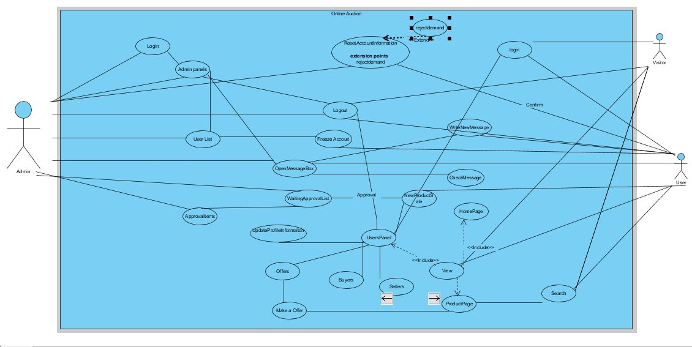

### Object model

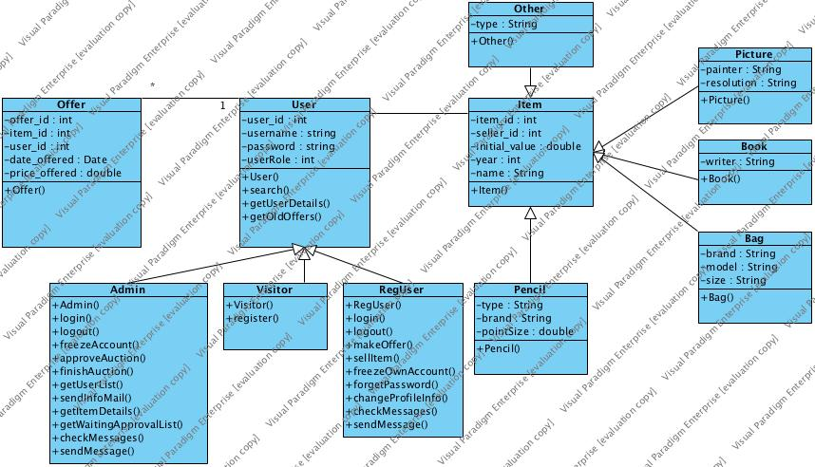

### Dynamic model

Admin Sequence Diagrams

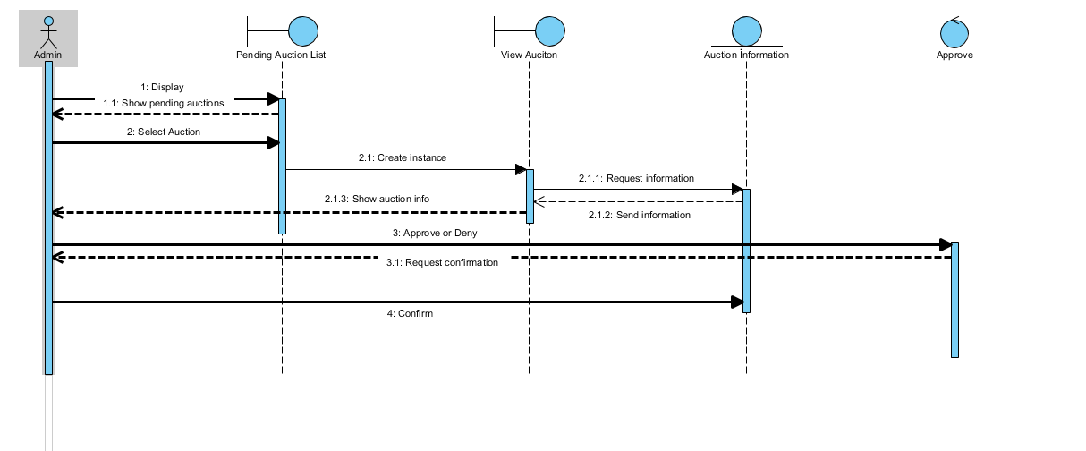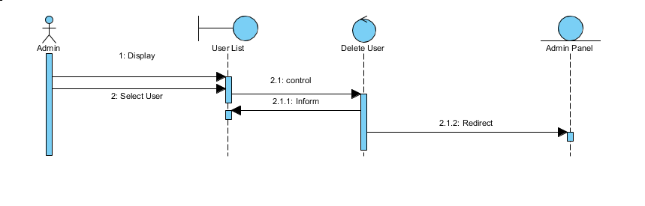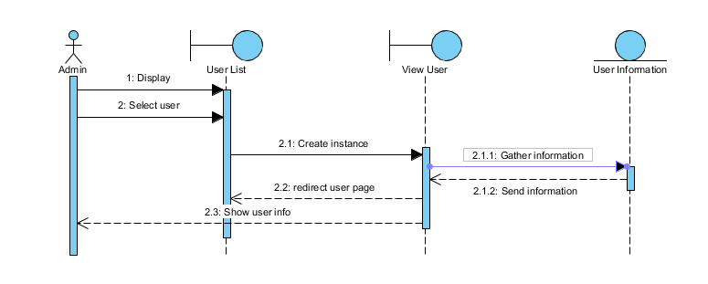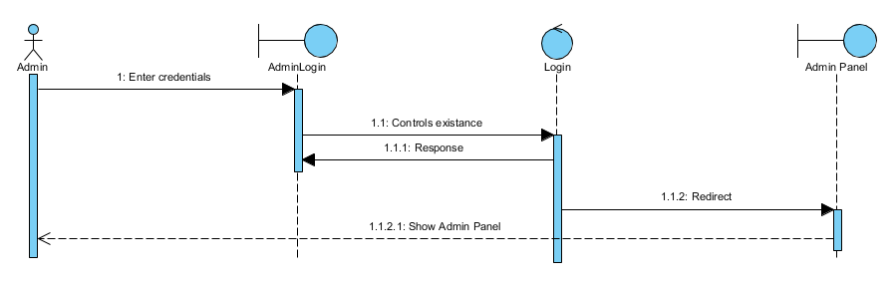

Registered User Sequence Diagrams

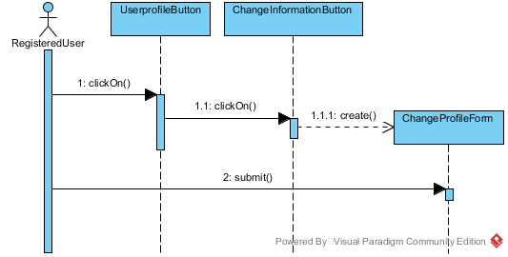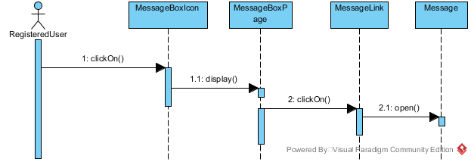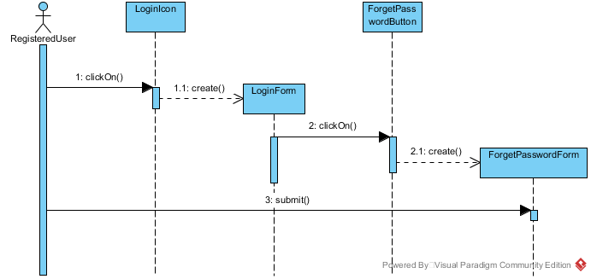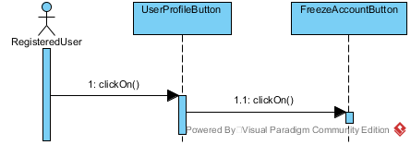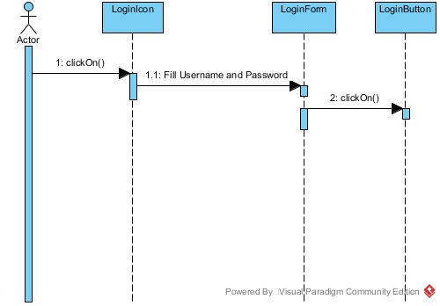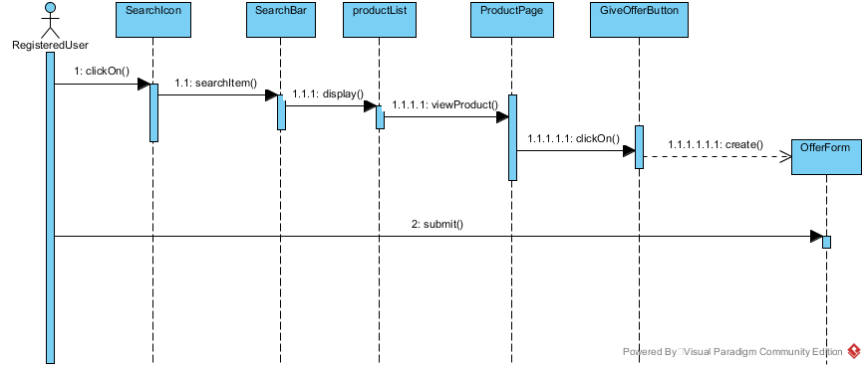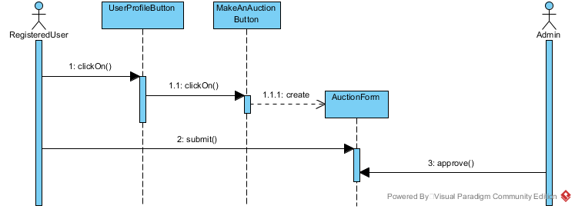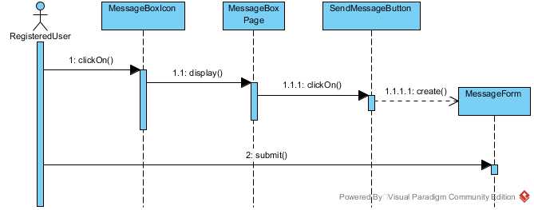

### User interface—navigational paths and screen mock-ups

Mockups PDF File is in the rar.

## Project Schedule

# Glossary

To establish a clear terminology, developers **identify the participating objects** for each use case. Developers should **identify, name, and describe them** unambiguously and collate them into a glossary.

# References

This subsection should:

* Provide a complete list of all documents referenced elsewhere in the RAD, or in a separate, specified document.
* Identify each document by title, report number - if applicable - date, and publishing organization.
* Specify the sources from which the references can be obtained.

The following is an example of listing a book in this section. Check the text to see how it is cross referenced (The whole document is based on [1]).

1. Bruegge B. & Dutoit A.H.. (2010). *Object-Oriented Software Engineering Using UML, Patterns, and Java*, Prentice Hall, 3rd ed.